EXPERIMENT-3
To implement a simple code generator that converts Three Address Code (TAC) into target machine instructions using C.

AIM:
To write a C program to implement a simple code generator that converts Three Address Code (TAC) into target machine instructions using MOV, ADD, SUB, MUL, and DIV instructions.
PSEUDOCODE:
- Start.
- Read TAC statements from the user.
- Repeat until the user enters END.
- Identify the operator and operands.
- Generate the corresponding MOV, ADD, SUB, MUL, or DIV instructions.
- Display the target code.
- Stop.

Program:
#include <stdio.h>
#include <string.h>

int main()
{
char result[20], op1[20], op2[20], oper;
char tac[100];
int i = 0;

printf("Enter Three Address Code:\n");
printf("Enter END to finish.\n");

while (1)
{
fgets(tac, sizeof(tac), stdin);

if (strncmp(tac, "END", 3) == 0)
break;

if (sscanf(tac, "%19s = %19s %c %19s",
result, op1, &oper, op2) == 4)
{
printf("MOV R%d, %s\n", i, op1);

switch (oper)
{
case '+': printf("ADD R%d, %s\n", i, op2); break;
case '-': printf("SUB R%d, %s\n", i, op2); break;
case '*': printf("MUL R%d, %s\n", i, op2); break;
case '/': printf("DIV R%d, %s\n", i, op2); break;
default:
printf("Invalid operator\n");
return 1;
}

printf("MOV %s, R%d\n", result, i);
}
else if (sscanf(tac, "%19s = %19s", result, op1) == 2)
{
printf("MOV %s, %s\n", result, op1);
}
else
{
printf("Invalid Three Address Code\n");
}

i++;
}

return 0;
}

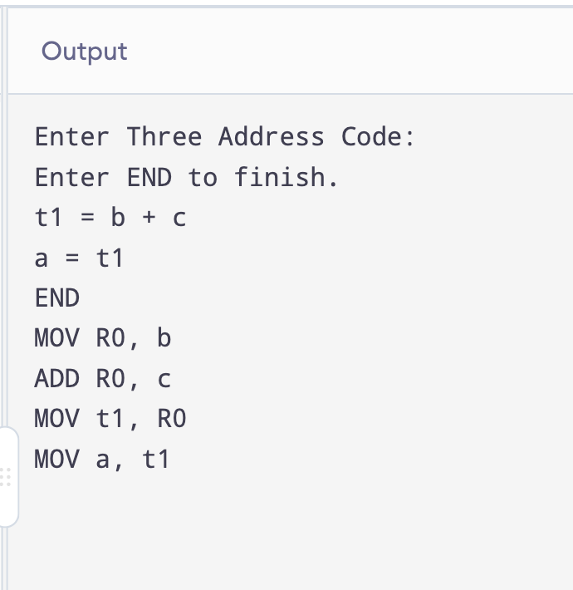
OUTPUT:

RESULT:

Thus, the C program to convert Three Address Code into target machine instructions was implemented and executed successfully.

